LAB 3 Assignment

Shuaiyu Liang (sl5352)

Tuesday 29th September, 2015

* 1. The source code of question 1 is in the package named Lab_3_ASGMNT1_1_sl5352.py

Recording of my own voice in stereo form is named the only thing that changes everything.wav

2-1. basic feedforward delay system with the delay of N samples is like the diagram below. The transfer function could be easily acquired that: 

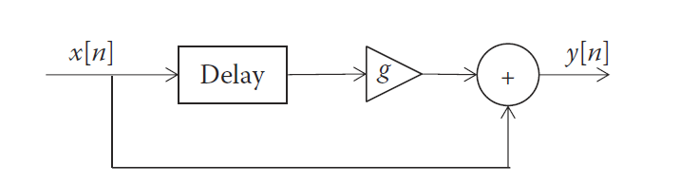

The transfer function has no poles outside the unit circle, the basic delay must be stable in all cases.

2-4. The source code for question 2-4 is in the package named Lab_3_ASGMNT2_4_sl5352.py

3-1.

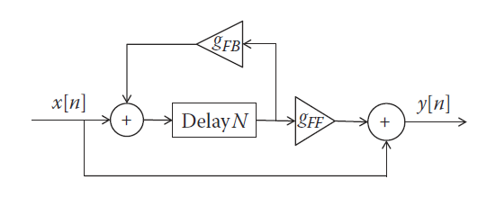

The delay system with feedforward and feedback could be represented as above diagram. With differential equation as 

Where  Think of  we then have. Then the transfer function goes like.This transfer function got poles at the N complex roots of. The condition for making the system stable is 

3-4 The source code for question 3-4 is in the package named Lab_3_ASGMNT3_4_sl5352.py